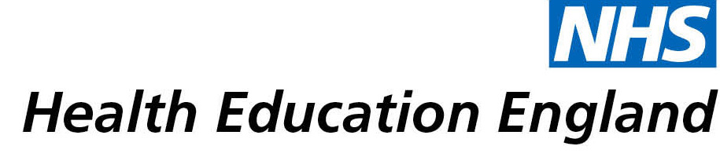

Library and Knowledge Services case study

Birmingham Community Healthcare NHS Foundation Trust – Smallwood Library: Academic support during the COVID pandemic
Date 13/07/2021

Reason for enquiry
The user was completing a Heart failure Master’s degree module delivered by the University of Hertfordshire. The course was a distance learning course that was meant to include 2 facilitated face-to-face study days prior to the pandemic. They had to complete a 5000 word dissertation and needed further support. They contacted the Library service for the provision of academic writing and Literature searching support.

“I've done academic writing and research and when I did do it, my last experience was at a Level 6 so Level 7 was completely new territory for me. So it just dawned on me what a fantastic resource the Smallwood Library Team were and I thought it might just be worth putting the feelers out because I remember hearing that the was support was there in terms of education and training for academic writing and literature searching so I thought I'd just put the feeler's out. The response was immediate. Very very supportive.”

What the knowledge and library specialist did
The Library Service arranged for the user to attend sessions where they were informed of tips that can be used to generate search strategies and how to navigate available healthcare databases. They were also offered support on how to write reflectively for academic pursuits.

“5000 words seems like a lot but when you have a targeted subject, you really need to narrow all of the searching down using all the healthcare resources whether it be CINAHL, Cochrane or the various search databases. I needed to be able to refine my searches adequately in order to answer the dissertation question. It was fundamental to me completing that assignment.”

Impact of input from the library and knowledge service
“It was outstanding. Very supportive. The team are very responsive and worked collaboratively with me to find a time and space bearing in mind that both sides of the services are very very busy during the pandemic. I'm happy to say that I've passed with flying colours. I managed to get a distinction and without the support I don't think I'd have anywhere close to that so very very appreciative.”

Immediate Impact
“It makes me a more competent knowledgeable clinician.”
“It saved massive amounts of time. I think I'd still be searching now if I hadn't spoken to one of your team.”

“It’s helped me to raise my already cardiac specialist qualifications and own knowledge to a higher level obviously moving into a heart failure perspective.”

“It's helped to enhance my own skills. It’s helped to support my continuous professional development in requirement for my nursing revalidation.”

“That’s the personal impact it’s had on me but it also translates into direct patient care and the advantages that it would provide them.”

Probable future Impact

Submission by:
Adam Sookia
Cardiac Specialist Nurse / Rehabilitation Team Leader

For further information on how you can get similar support contact your local NHS library and knowledge service.

Submission Details

Name of Organisation Birmingham Community Healthcare NHS Foundation Trust

Knowledge and Library Service Contact Email smallwood.library@nhs.net

NHS Region Midlands

Title of Case Study Academic support during the COVID pandemic

Sector Community

Group Impacted Nursing and Midwifery

Impact Types [Please select any which apply]
Contributed to personal or professional development.
Contributed to service development or delivery.
Facilitated collaborative working.
Health Information for Patients, Carers and the Public.
Improved the quality of patient care.
Mobilising evidence and organisational knowledge.
More informed decision making.
Productivity and efficiency.
Reduced risk or improved safety.
Saved money or contributed to financial effectiveness.
Improved health and wellbeing of staff and learners

Consent
I have consent from individuals referred to in this case study to share details nationally for advocacy and promotion. [Make bold the option which applies:]
Yes

