Resource Discovery Usage Data Dashboards

Contents
What’s being measured by each dashboard? 1
Main features 1
Regions and organisation filters 2
How does your usage compare to other similar Trusts in your region? 4

These dashboards show comparative usage data for the following metrics:
- Hub Requests
- BMJBP Impressions
- OA Accounts
- LibKey Requests
- Royal Marsden

What’s being measured by each dashboard?

Hub Requests
Total number of full text and abstract requests being made by users of the NHS Knowledge and Library Hub.

BMJBP Impressions
The total number of pages loaded into the desktop version of BMJ Best Practice or the app.

OA Accounts
The total number of OpenAthens accounts. In the column hover data, you’ll also find total number of successful authentications and of the percentage of these against the total.

LibKey Requests
The total number of requests for full text being made from any LibKey product, including LibKey Discovery used on the NHS Knowledge and Library Hub and LibKey Nomad.

Royal Marsden
Total item requests for Royal Marsden Manual of Clinical Nursing Procedures. Each time a chapter is opened, an item request is recorded.

Main features
Each dashboard is split into three levels: national; regional; and Trust.
Data may be filtered by:
- Region
- Trust
- Organisation type
- Organisation tier
- Month/year
Multiple filters may be used at the same time.
Each level may be toggled to show data by month, quarter and year.
Data may also be filtered by increase, decrease or no change at national, regional and Trust level.
A median line dynamically responds to the filters you add.
Click or hover on the columns to see additional information, including percentages.
Remember:
- The levels scroll horizontally.
- To show the data by month, quarter or year, hover over the date bar and click the plus or minus symbols.
- 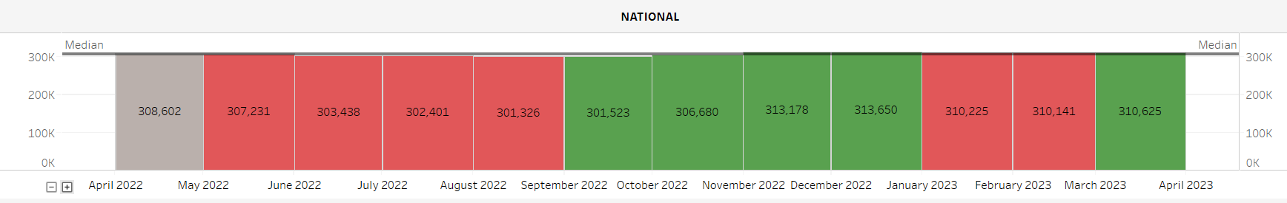

Regions and organisation filters

Regions
- East of England
- London
- Midlands
- National
- North East and Yorkshire
- North West
- South East
- South West

Organisation Type
- Acute
- Acute/Community Health
- Community Health
- Higher Education
- Mental Health
- Mental/Community Health
- National
- Other
- Primary Care

Organisation Tier
- 1 – Super Organisations (>14,000 FTEs)
- 2 – Large organisations (>8,000-<=14,000FTEs)
- 3 – Medium organisations (>3,000 – <=8,000 FTEs)
- 4 – Small organisations (<= 3,000 FTEs)
- HEIs (Higher Education Institutions)
- No Tier
See which organisations are included within each type and tier.

How does your usage compare to other similar Trusts in your region?
Medians are used for comparison. Median lines are included on the dashboards. They are dynamic and will change depending on the data being presented.
The median is the mid-point in a range of data values. We prefer it to the mean or average, as median overcomes skewing due to outliers in the data.
We usually look at the median of Trusts of same size and type in your region.

Step 1
Check your organisation for its type and tier.

Step 2
Open the Tableau dashboards and select the dashboard you want to use. Note that you will need to be given access to Tableau. Request access via the Service Desk.

Step 3
Filter the data to show organisations of your size and type. If your organisation is an acute Trust in tier 3 in the North West.
- Select the down arrow next to Organisation Type and deselect all options by clicking All. Once all option boxes are black, select Acute.
- Select the down arrow next to Organisation Tier and deselect all options by clicking All. Once all option boxes are black, select 3-Medium Organisations.
- Select the down arrow next to Region and deselect all options by clicking All. Once all option boxes are black, select North West.

Step 4
In this example, all the tier 3 acute Trusts in the North West are displayed in the Trusts section of the dashboard.
The median line shows the median for all of the Trusts. Make a note of it.

Step 5
Now select your own Trust to find your median. Select the down arrow next to Trust Name and deselect all options by clicking All. Once all option boxes are black, select your own Trust.
Make a note of your median. Is it above or below the median for all similar Trusts in your region?
If it is above, you can be reassured that your usage of the resource is good. If it is below, find a Trust with usage significantly above the median for all similar Trusts in your region, and ask what they have been doing to achieve it.

